Single parameter:

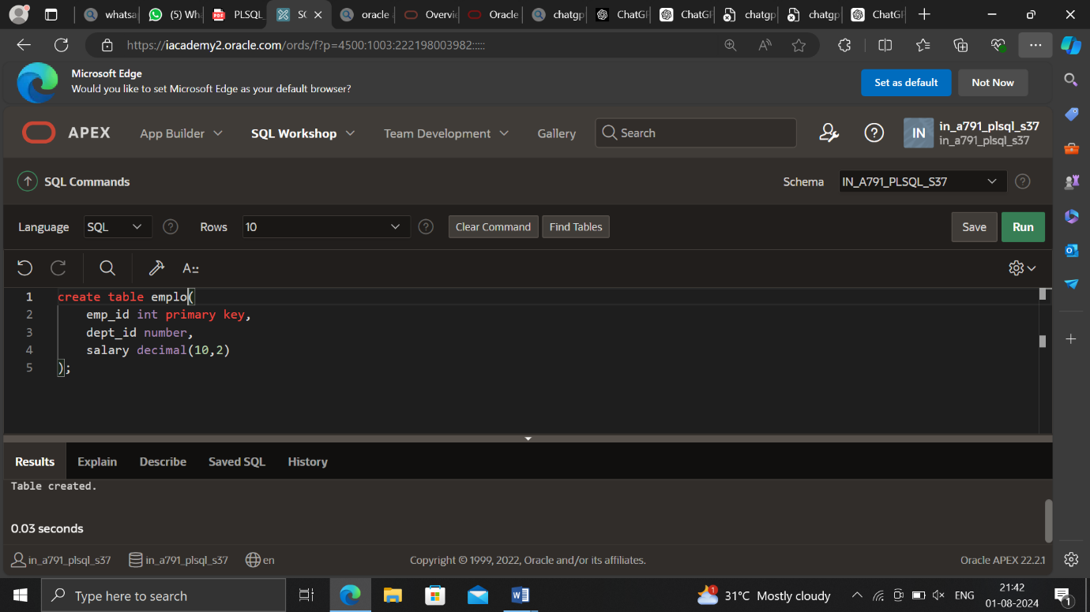

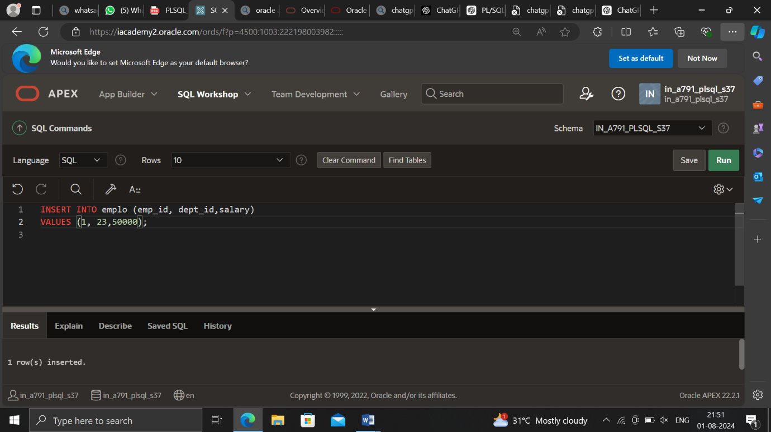

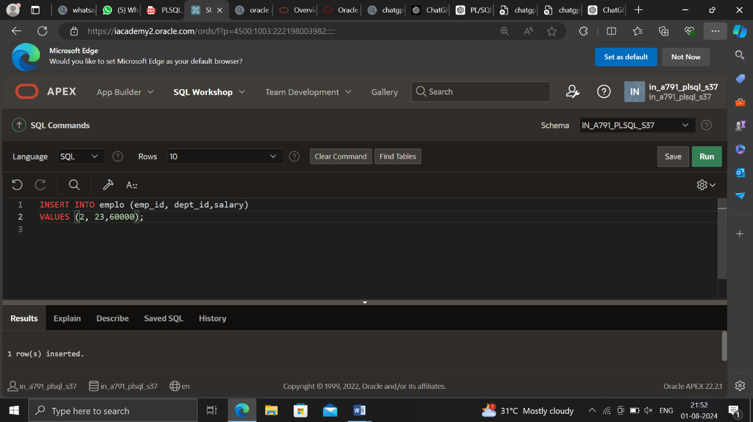

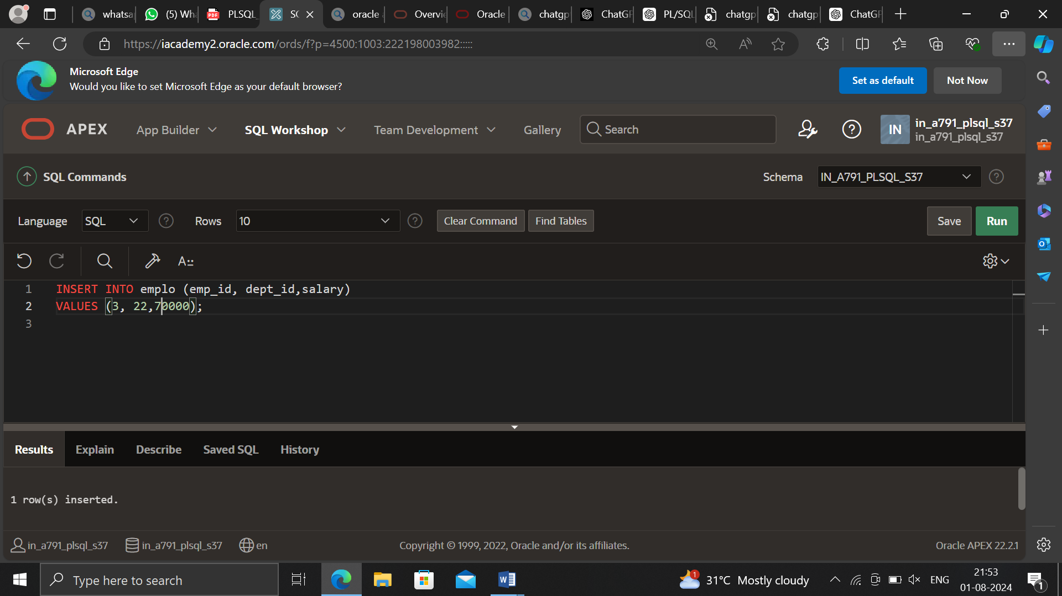

DECLARE

v_deptid employees.department_id%TYPE;

CURSOR cur_emps (p_deptid NUMBER) IS

SELECT employee_id, salary

FROM employees

WHERE department_id = p_deptid;

v_emp_rec cur_emps%ROWTYPE;

BEGIN

SELECT MAX(department_id) INTO v_deptid

FROM employees;

OPEN cur_emps(v_deptid);

LOOP

FETCH cur_emps INTO v_emp_rec;

EXIT WHEN cur_emps%NOTFOUND;

DBMS_OUTPUT.PUT_LINE(v_emp_rec.employee_id || ' '

|| v_emp_rec.salary);

END LOOP;

CLOSE cur_emps;

END;

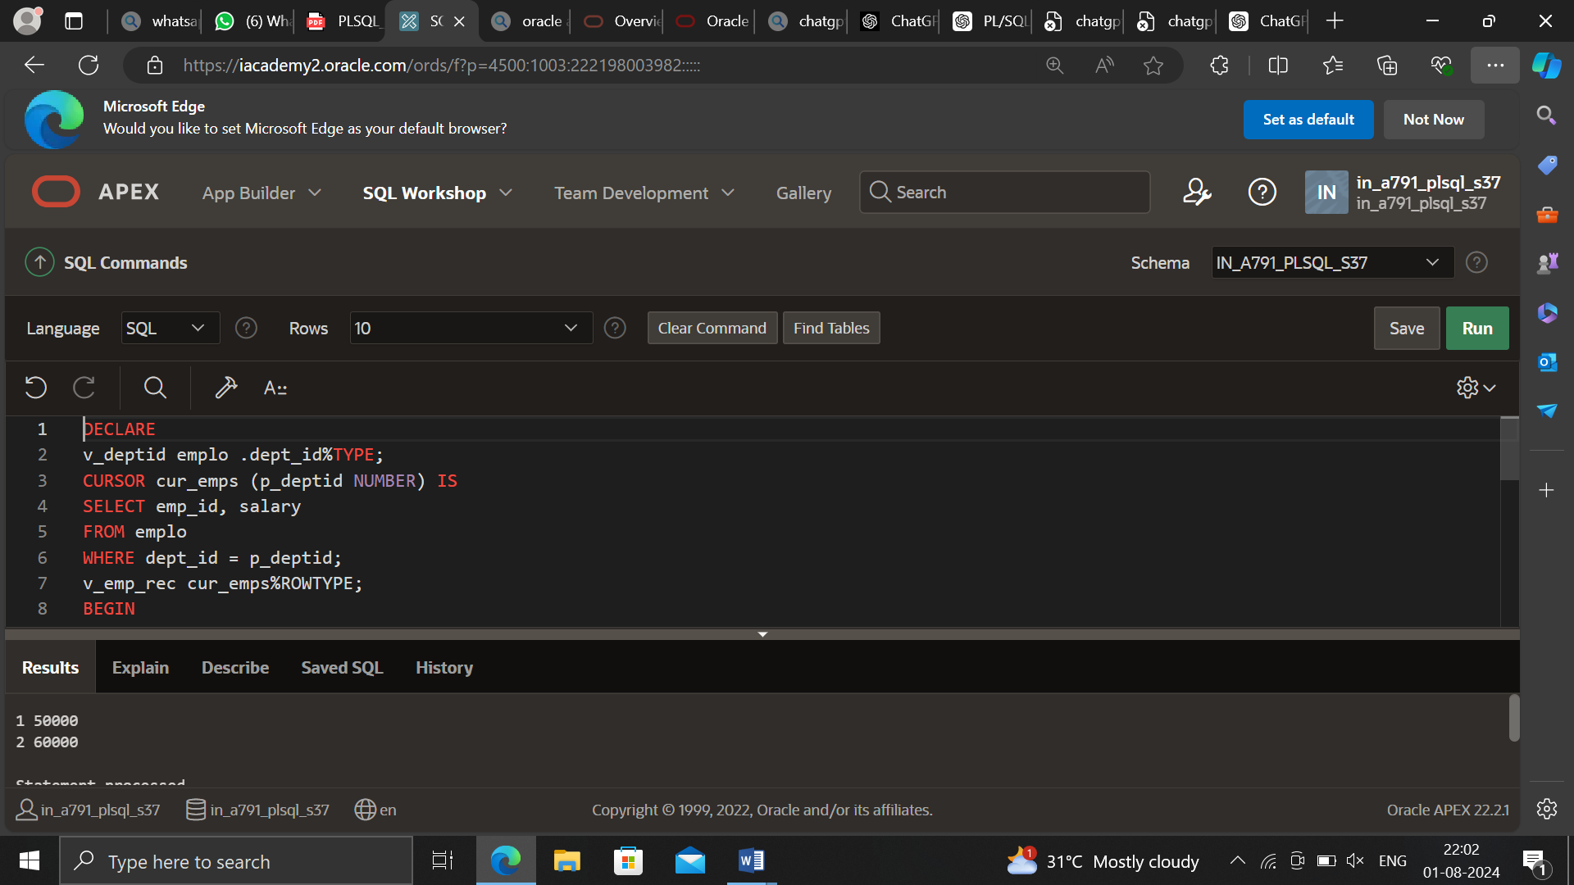

Multiple parameters:

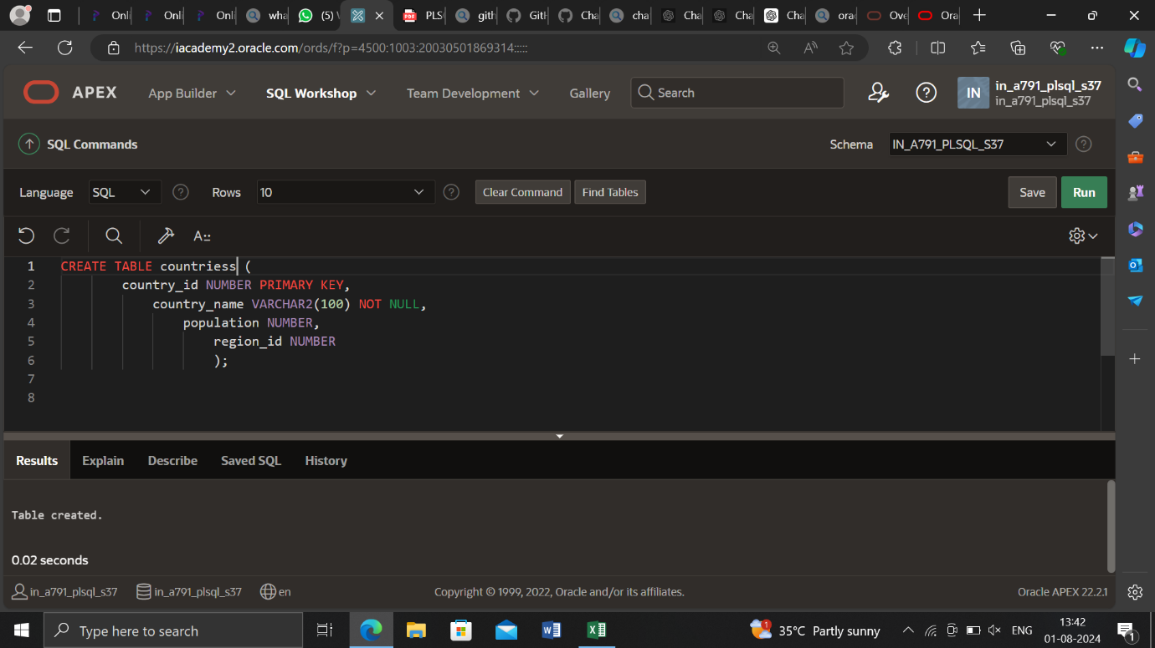

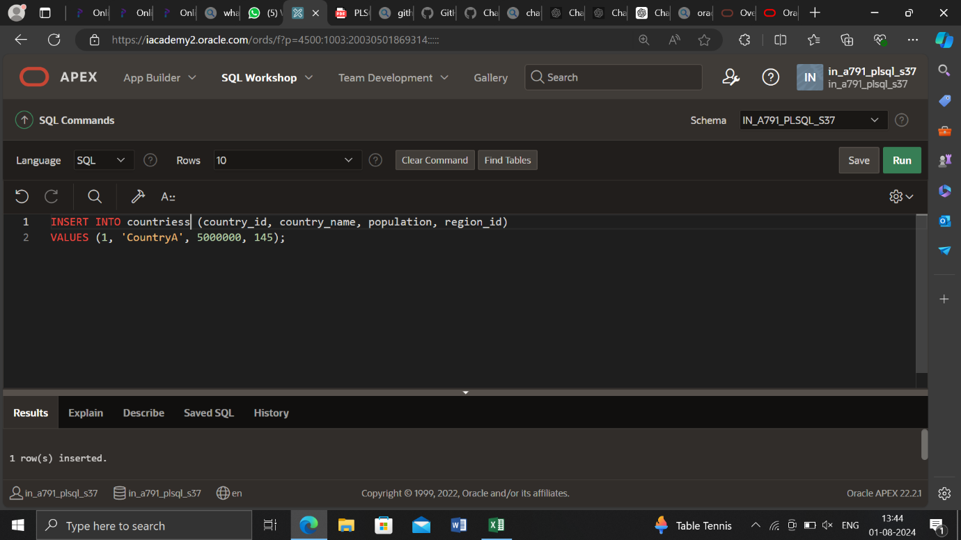

Example 1:

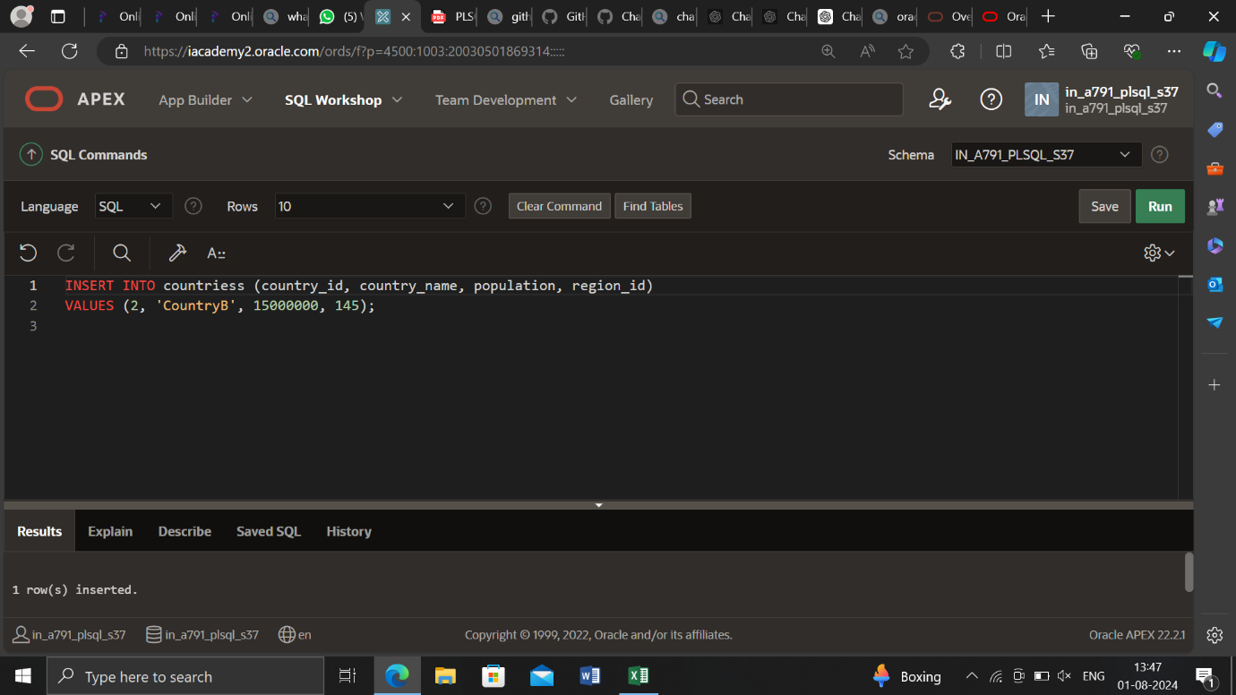

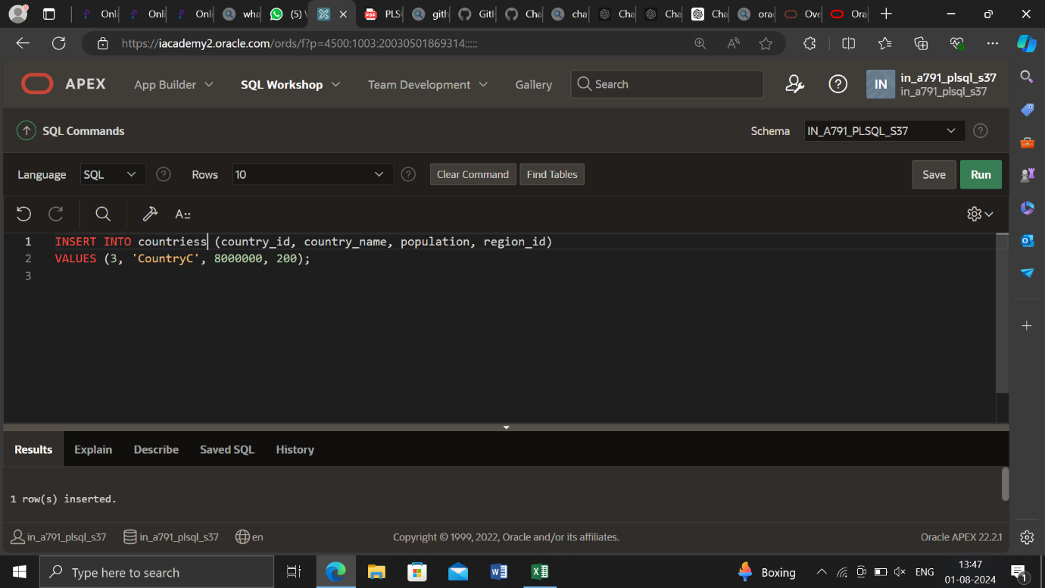

DECLARE

CURSOR cur_countries (p_region_id NUMBER, p_population

NUMBER) IS

SELECT country_id, country_name, population

FROM countries

WHERE region_id = p_region_id

OR population > p_population;

BEGIN

FOR v_country_record IN cur_countries(145,10000000) LOOP

DBMS_OUTPUT.PUT_LINE(v_country_record.country_id ||' '

|| v_country_record. country_name||'

'

|| v_country_record.population);

END LOOP;

END;

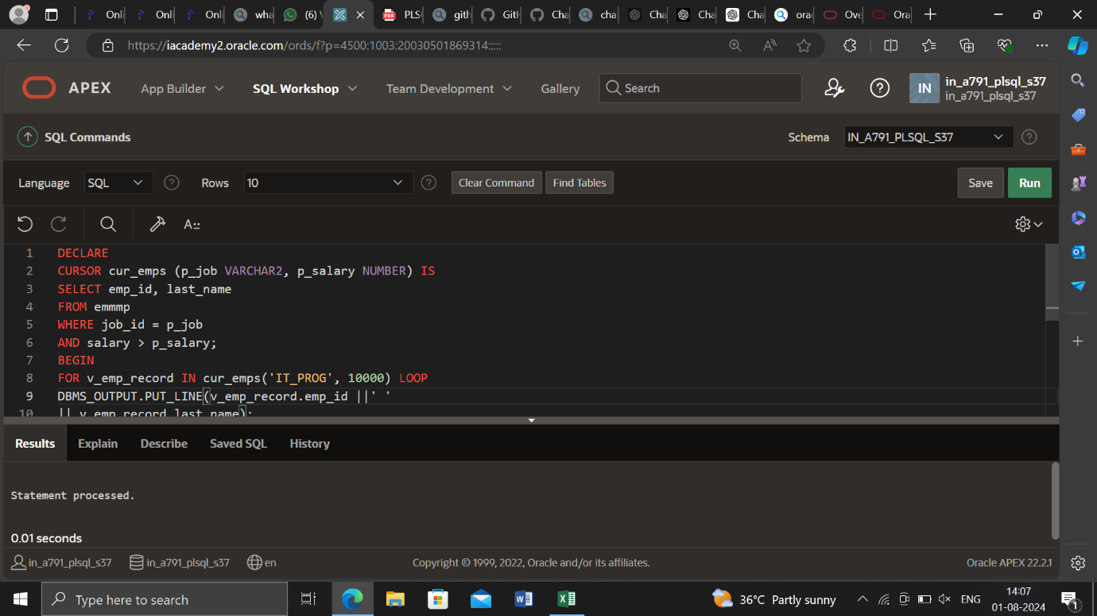

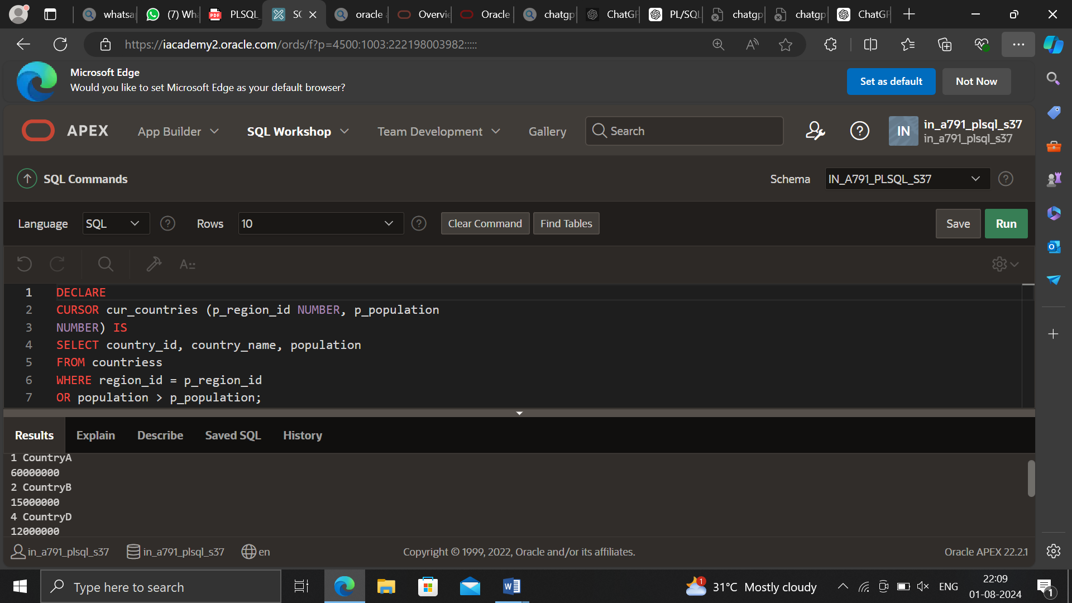

Example :2

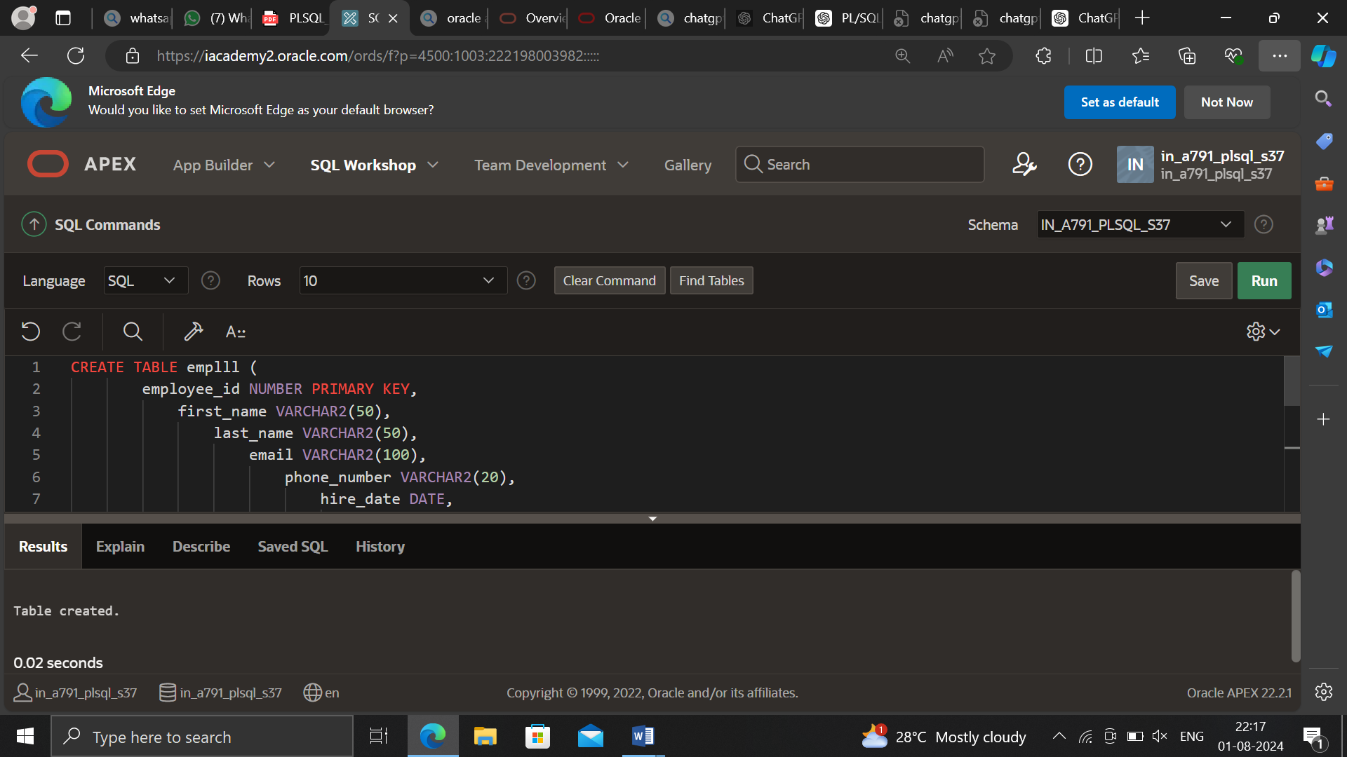

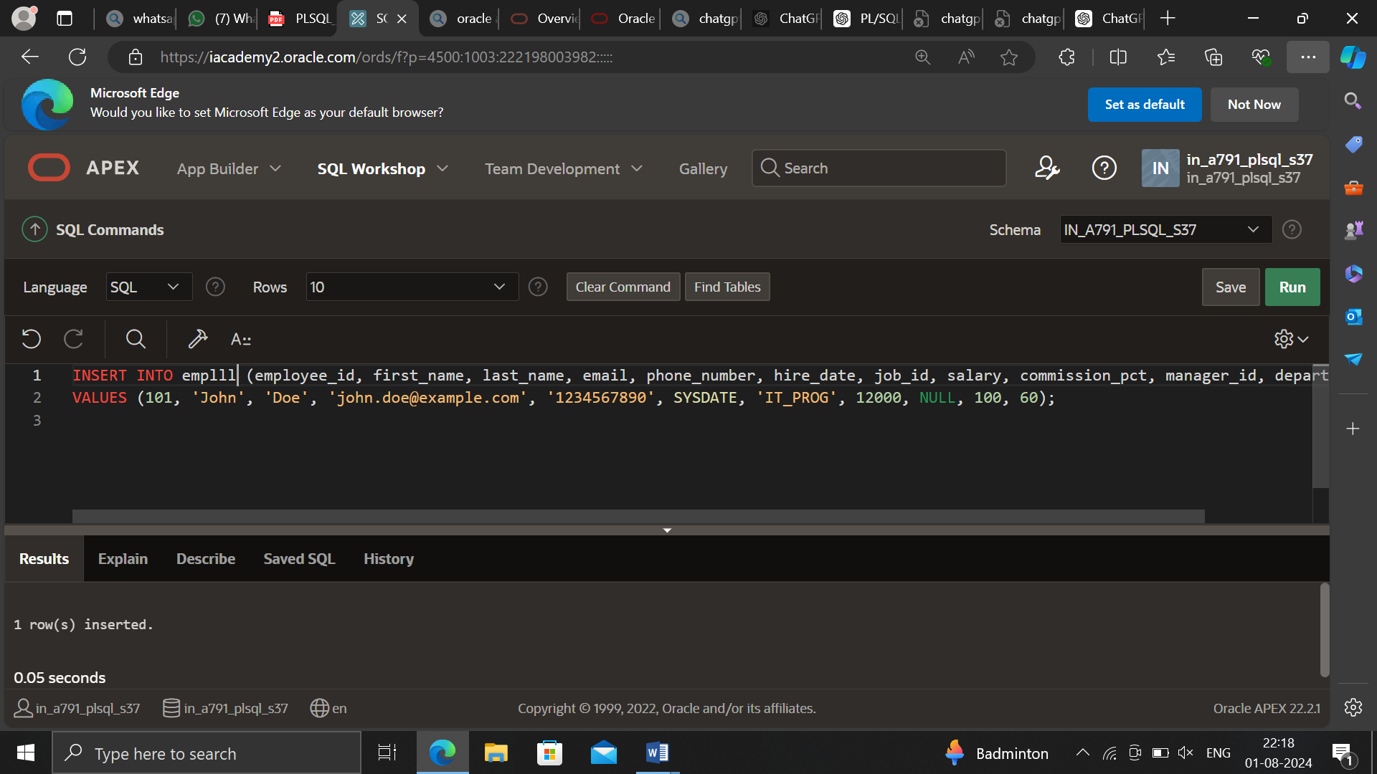

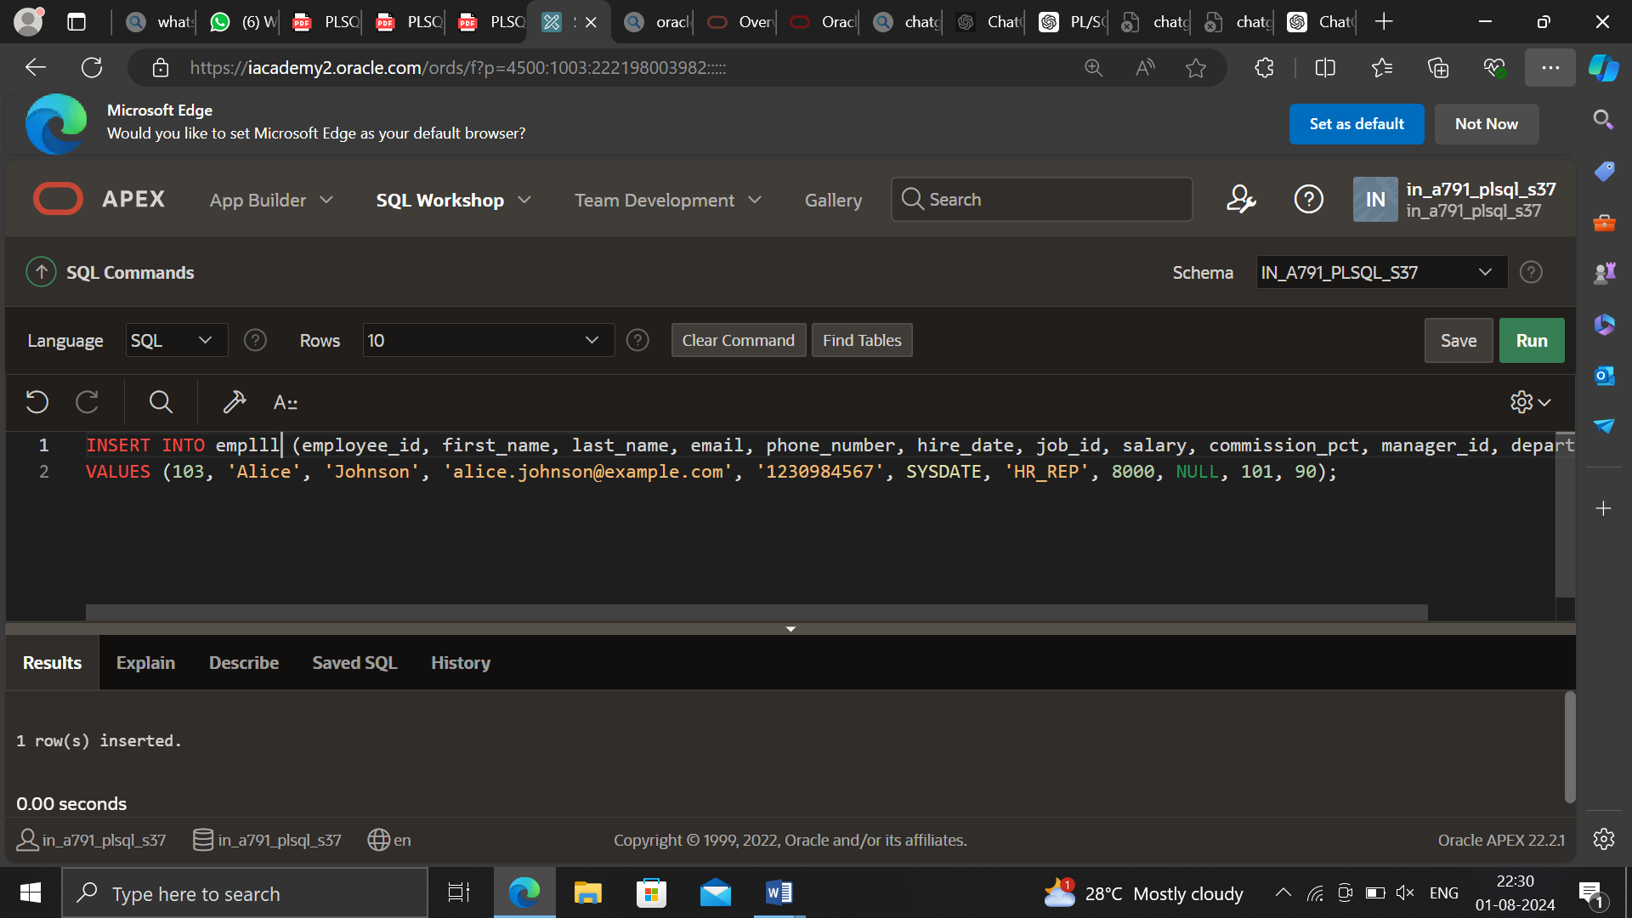

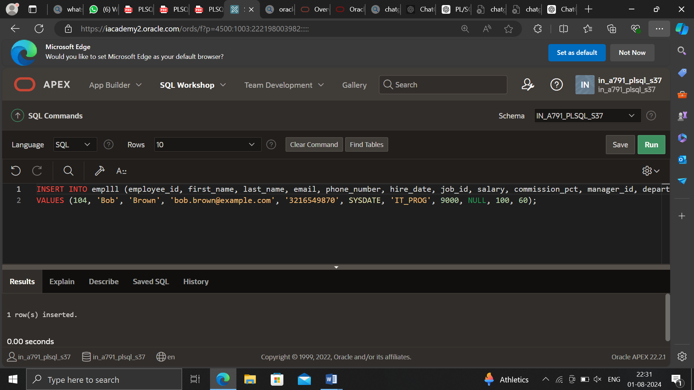

DECLARE

-- Define a cursor with two parameters

CURSOR cur_emps (p_job VARCHAR2, p_salary NUMBER) IS

SELECT employee_id, last_name

FROM employees

WHERE job_id = p_job

AND salary > p_salary;

BEGIN

-- Loop through the cursor with specific parameter values

FOR v_emp_record IN cur_emps('IT_PROG', 10000) LOOP

DBMS_OUTPUT.PUT_LINE(v_emp_record.employee_id || ' ' || v_emp_record.last_name);

END LOOP;

END;

/

